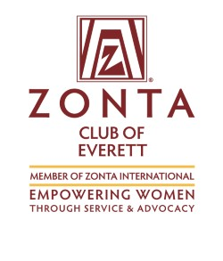
APPLICATION FOR FUNDING
Since 1929 Zonta Club of Everett Foundation has provided assistance to non-profit organizations serving the citizens of Snohomish County using proceeds from the club’s fund raising activities. The focus of our organization is to fund opportunities for women to develop new skills and gain economic security. In an effort to achieve that goal, each year the Zonta Club of Everett awards grants to non-profit organizations whose programs align with Zonta’s mission.
Organization Name/Address:_____________________________________________________________
_____________________________________________________________________________________
Contact person/Title/Phone/Email:________________________________________________________
_____________________________________________________________________________________
_____________________________________________________________________________________
Purpose/Mission of Organization:________________________________________________________________________________________________________________________________________________________________________________________________________________________________________________________________________________________________________________________________________________________________________________________________________________________________________________________________________________________________________________________________________________________________________________________________________
Describe specific program for which funds are requested, and what difference it would make for your agency. Attach additional sheets if necessary.
Program Title & Description:______________________________________________________________________________________________________________________________________________________________________________________________________________________________________________________________________________________________________________________________________________________________________________________________________________________________________________________________________________________________________________________________________________________________________________________________________________________________________________________________________________________________
Amount Requested:____________________________________________________________________
Please attach hands-on projects your agency needs. Describe the project, time of year, number of hours, and number of individuals needed to complete the project. Attach additional sheets if necessary. We wish to encourage multiple one-time projects that can take place any time throughout the year including smaller projects that might need just a few volunteers. _____________________________________________________________________________________ ___________________________________________________________________________________________________________________________________________________________________________________________________________________________________________________________________________________________________________________________________________________________________________________________________________________________________________________________________________________________________________________________________________________________________________________________________________________

Has your agency received Zonta funds in the past? Please list date(s) and amount(s).___________________________________________________________________________________________________________________________________________________________________________________________________________________________________________________________________________________________________________________________________________

Return application by Thursday, January 18, 2018 to:
Zonta Club of Everett Foundation
ATTN: Marilyn Marsh, Service Committee
P.O.Box 5204
Everett, WA
98206-5204
Or email application to marilyn@jmarsh.com

Contacts: Marilyn Marsh, Service Chair marilyn@jmarsh.com
kelseytaylor@housinghope.org

