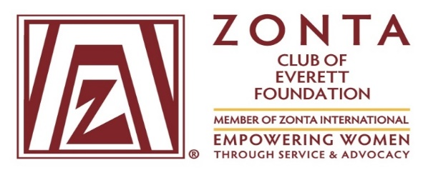
AEROSPACE AND ADVANCED MANUFACTURING SCHOLARSHIP AWARD
The Zonta Club of Everett recognizes young women 16-19 years of age who are interested in career pathways in aerospace manufacturing, including welding, fabrication, machining, engineering technology, composites technology and mechatronics; females interested in nontraditional jobs in manufacturing (even if they are unsure of what to pursue) and females interested in attending any of the certified or degree programs at AMTEC, the Advanced Manufacturing Training and Education Center, Everett, Washington.
Application deadline is March 31, 2017.
Applicants must demonstrate initiative in personal goals and financial need.
Personal Information:
Name_____________________________________________ Email ____________________
Address____________________________________________Phone____________________
Educational Background:
High School __________________________________________________________________
GPA___________________ Year Graduated_________________________________________
Financial Information:
Currently Working: Yes______ No______ Where?____________________________________
Monthly Income_______________________________________________________________
On Public Assistance: Yes____ No______
Other income Source: Yes____ No______ How much?_________________________________

Goals Statement:
On a separate sheet, please describe your educational goals, career and employment plans and other aspirations. Describe how your education at AMTEC will help you achieve those goals.
Community Involvement:
On a separate sheet, please describe what activities you have participated in or are currently involved in which have broadened your education beyond academic studies.
Current Need:
On a separate sheet, please describe your current need for the AMTEC scholarship and why you feel you should receive it.
Attachments:
- Two letters of reference from adults not related to you.
- Goals Statement; Community Involvement Statement; Need Statement.
I have completed this application with the best information available, and I hereby attest to its accuracy. I give my permission for the Zonta Club of Everett to release my name and photo in any publication or social media if I am a recipient of the scholarship.

Signature:___________________________________________ Date___________________
Print Name:_________________________________________________________________
Application must be received by March 31, 2017 and mailed to:
Service Committee, Zonta Club of Everett, P.O. Box 5204, Everett,WA 98206
If you have any questions, please contact Zonta Service Committee members:
Marilyn Marsh at Marilyn@jmarsh.com or
Judith Strand at Judith_strand39@msn.com.

